**Neural Network: Architecture**

Neural Networks are complex structures made of artificial neurons that can take in multiple inputs to produce a single output. This is the primary job of a Neural Network – to transform input into a meaningful output. Usually, a Neural Network consists of an input and output layer with one or multiple hidden layers within. It is also known as Artificial Neural Network or ANN. ANN architecture in Neural Network functions just like a human brain and is very important.

In a Neural Network, all the neurons influence each other, and hence, they are all connected. The network can acknowledge and observe every aspect of the dataset at hand and how the different parts of data may or may not relate to each other. This is how Neural Networks are capable of finding extremely complex patterns in vast volumes of data.

**In a Neural Network, the flow of information occurs in two ways –**

* **Feedforward Networks:** In this model, the signals only travel in one direction, towards the output layer. Feedforward Networks have an input layer and a single output layer with zero or multiple hidden layers. They are widely used in pattern recognition.
* **Feedback Networks:** In this model, the recurrent or interactive networks use their internal state (memory) to process the sequence of inputs. In them, signals can travel in both directions through the loops (hidden layer/s) in the network. They are typically used in time-series and sequential tasks.

**Neural Network: Components**

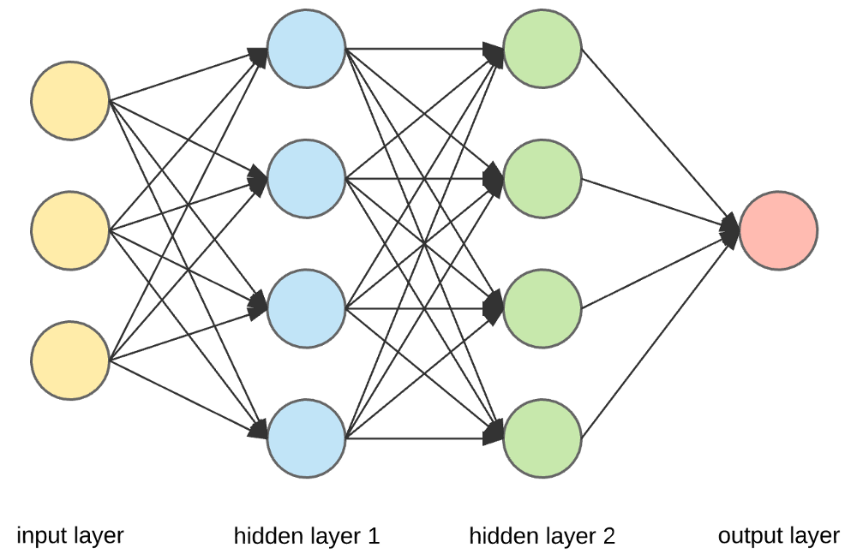

**Input Layers, Neurons, and Weights** –

In the picture given above, the outermost yellow layer is the input layer. A neuron is the basic unit of a neural network. They receive input from an external source or other nodes. Each node is connected with another node from the next layer, and each such connection has a particular weight. Weights are assigned to a neuron based on its relative importance against other inputs.

When all the node values from the yellow layer are multiplied (along with their weight) and summarized, it generates a value for the first hidden layer. Based on the summarized value, the blue layer has a predefined “activation” function that determines whether or not this node will be “activated” and how “active” it will be.

Let’s understand this using a simple everyday task – making tea. In the tea making process, the ingredients used to make tea (water, tea leaves, milk, sugar, and spices) are the “neurons” since they make up the starting points of the process. The amount of each ingredient represents the “weight.” Once you put in the tea leaves in the water and add the sugar, spices, and milk in the pan, all the ingredients will mix and transform into another state. This transformation process represents the “activation function.”

**Hidden Layers and Output Layer** –

The layer or layers hidden between the input and output layer is known as the hidden layer. It is called the hidden layer since it is always hidden from the external world. The main computation of a Neural Network takes place in the hidden layers. So, the hidden layer takes all the inputs from the input layer and performs the necessary calculation to generate a result. This result is then forwarded to the output layer so that the user can view the result of the computation.

In our tea-making example, when we mix all the ingredients, the formulation changes its state and color on heating. The ingredients represent the hidden layers. Here heating represents the activation process that finally delivers the result – tea.

**Neural Network: Algorithms**

In a Neural Network, the learning (or training) process is initiated by dividing the data into three different sets:

* **Training dataset –** This dataset allows the Neural Network to understand the weights between nodes.
* **Validation dataset –** This dataset is used for fine-tuning the performance of the Neural Network.
* **Test dataset –** This dataset is used to determine the accuracy and margin of error of the Neural Network.